**PROJECT-6**:

# **CREATING A CUSTOM VPC FROM SCRATCH:**

## VPC stands for Virtual Private Cloud and is a key component of Amazon Web Services (AWS).

## It is a logically isolated virtual network within the AWS cloud where you can launch AWS resources such as EC2 instances, RDS databases, and more.

## A VPC provides isolation at the networking level, allowing you to define your own IP address range, subnets, route tables, and network gateways.

## Within a VPC, you can create multiple subnets in different availability zones. Subnets are subdivisions of the VPC's IP address range and can be public or private.

## Public subnets are associated with a route table that has an internet gateway, allowing resources within the subnet to have direct access to the internet.

## VPCs provide security features such as security groups and network access control lists (ACLs).

## Security groups act as virtual firewalls, controlling inbound and outbound traffic at the instance level, while ACLs operate at the subnet level, controlling traffic between subnets.

## VPCs can be connected to your on-premises data centers or other VPCs in different AWS regions using Virtual Private Network (VPN) or AWS Direct Connect.

## VPC endpoints allow you to privately access AWS services without requiring internet access.

# STEPS:

1.Create a VPC 10.0.0.0/16 - 65536 IP addresses.

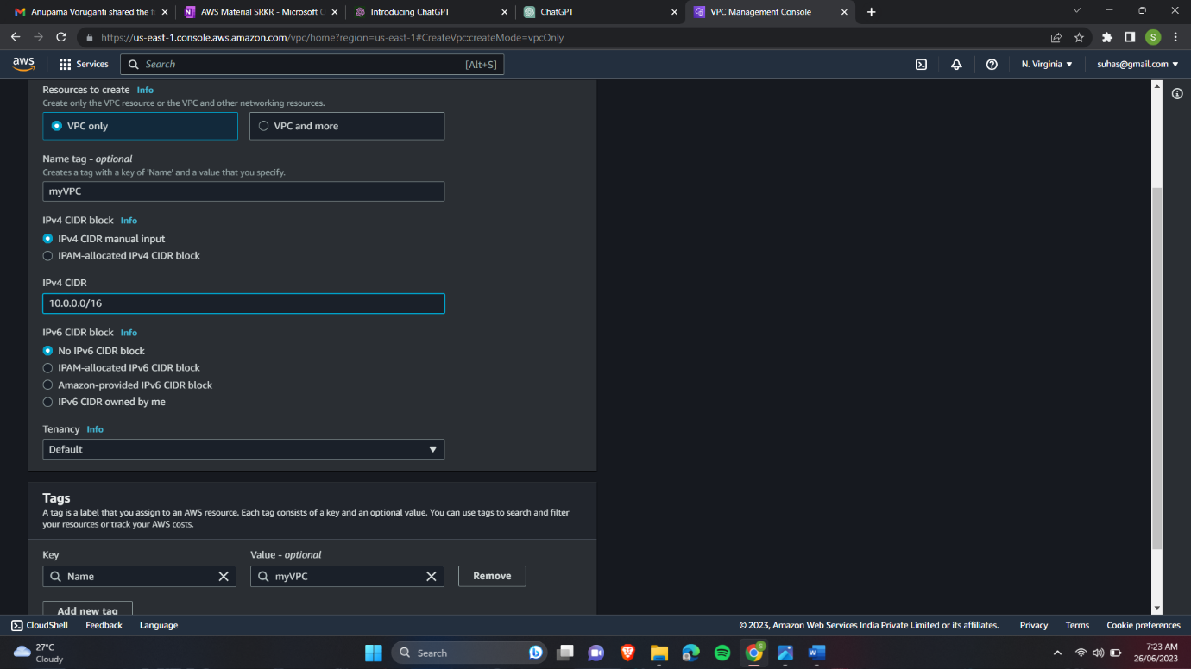

2.Create public and private subnets 10.0.1.0/24, 10.0.2.0/24.

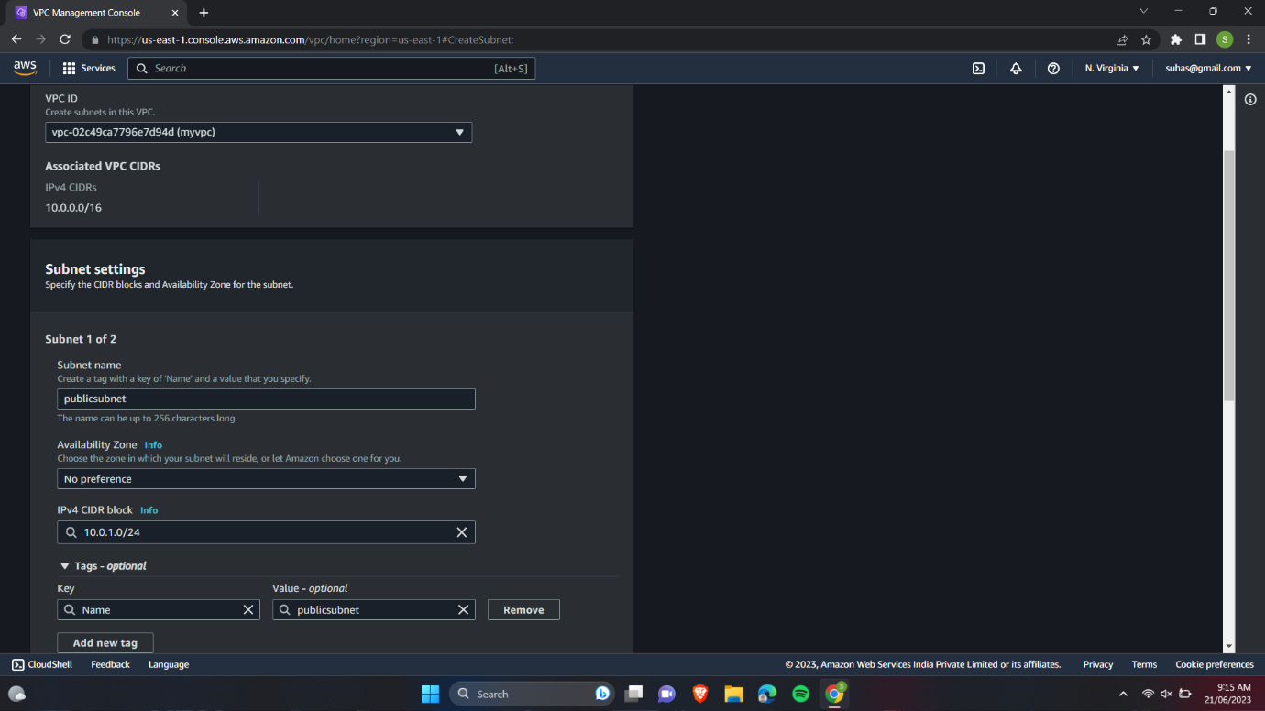

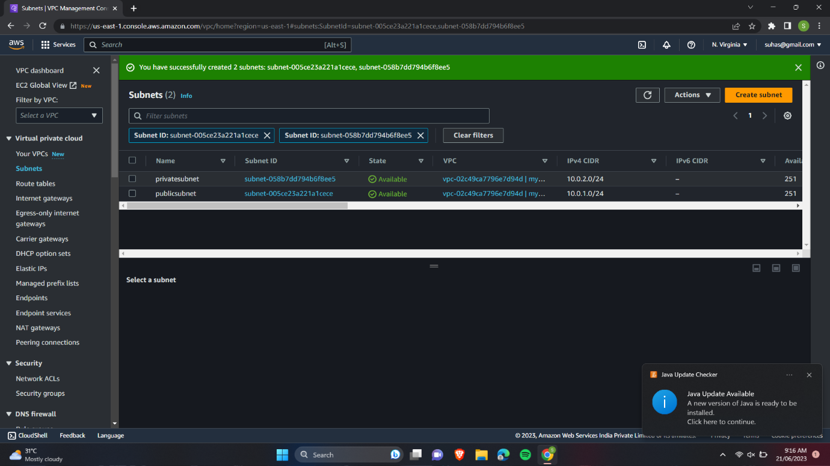

3.Enable Auto assign public Ip enable for public subnet.

4.create public and private route table.

5.create internet gateway.

6.Attach Internet gateway to VPC.

7.Add Internet gateway as a route to public route table with destination 0.0.0.0/0.

8.Create NAT Instance.

9.Add NAT Instance as a route in the private route table with destination 0.0.0.0/0 (optional).

10.Associate public subnet to public route table.

11.Associate private subnet to private route table.

12.Create a public instance in public subnet.

13.Create a private instance in private subnet.

14.Connecting to our public instance using git-bash.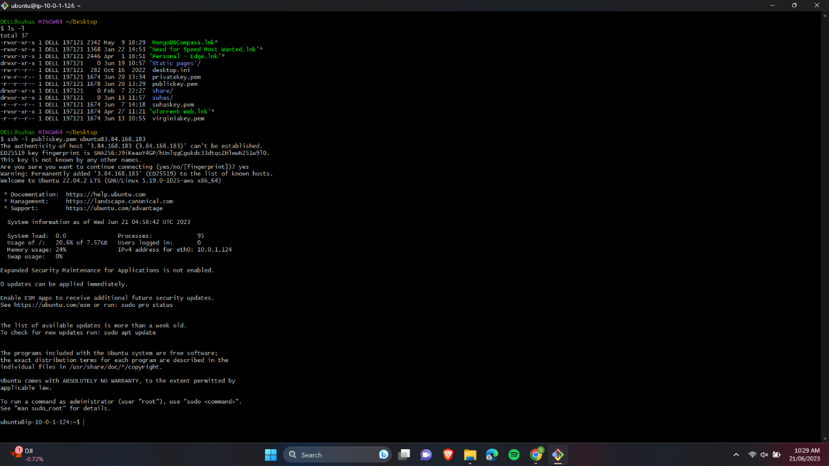

15.Updating our Ubnutu using sudo apt-get update.

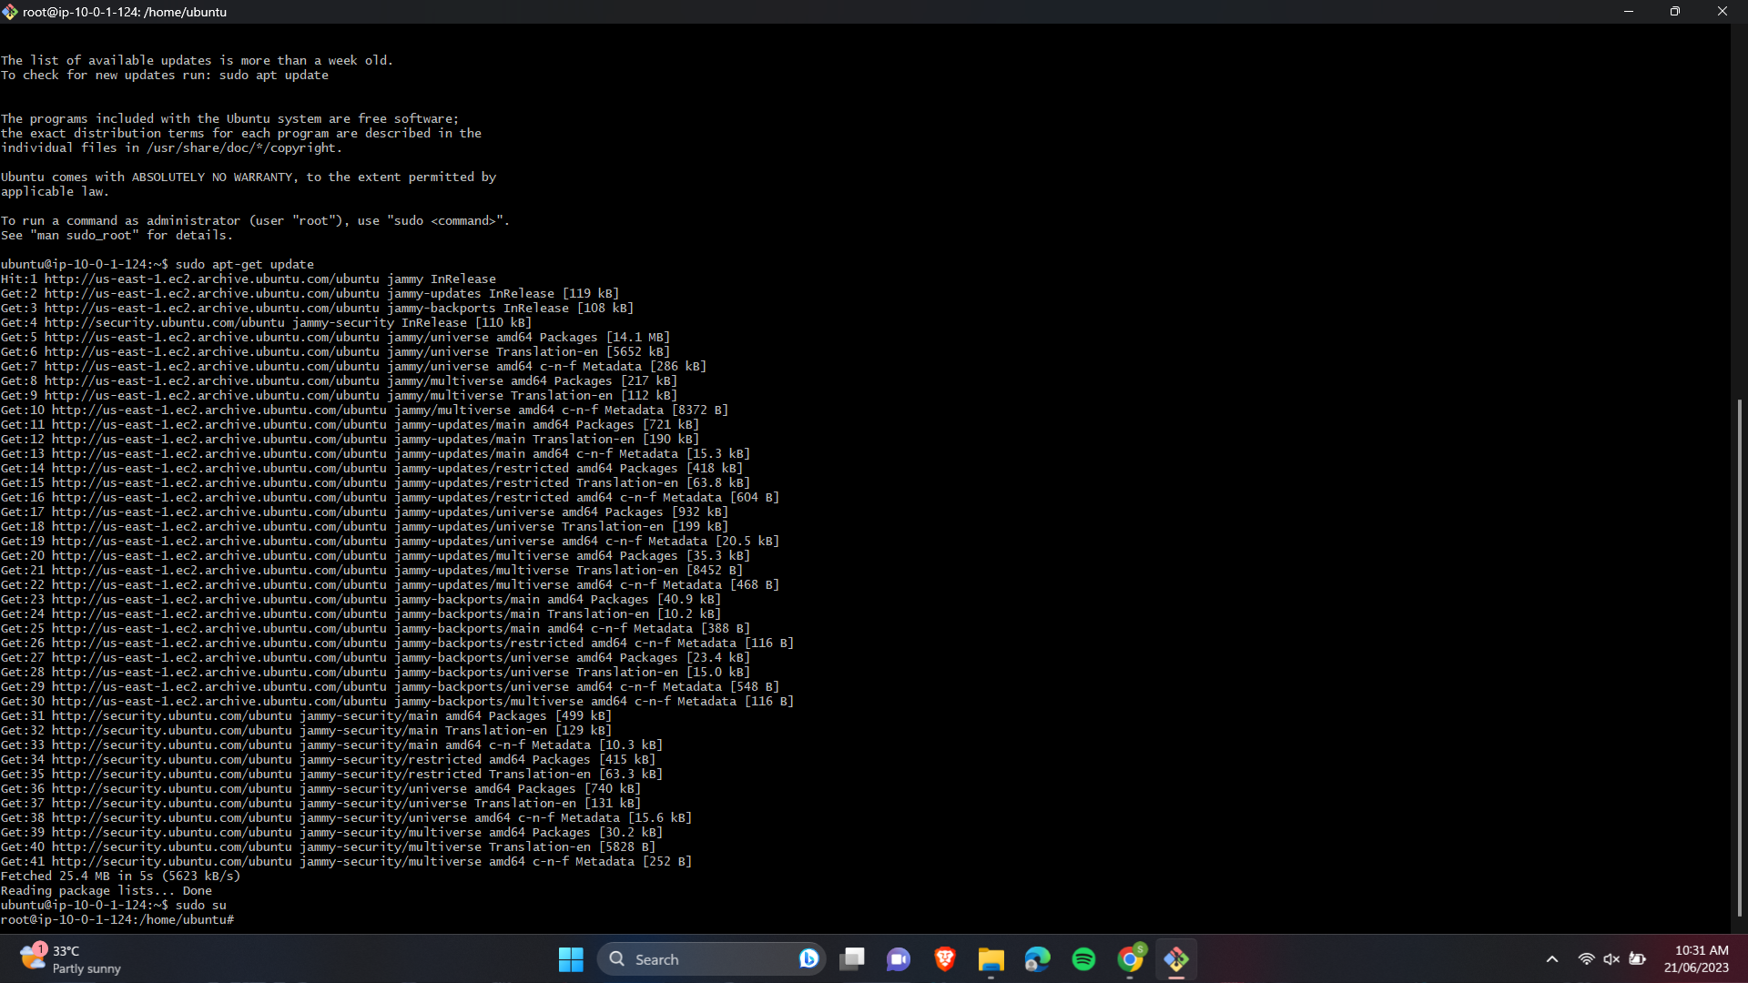

16.Changing the permissions of opt folder and logging out of our instance.

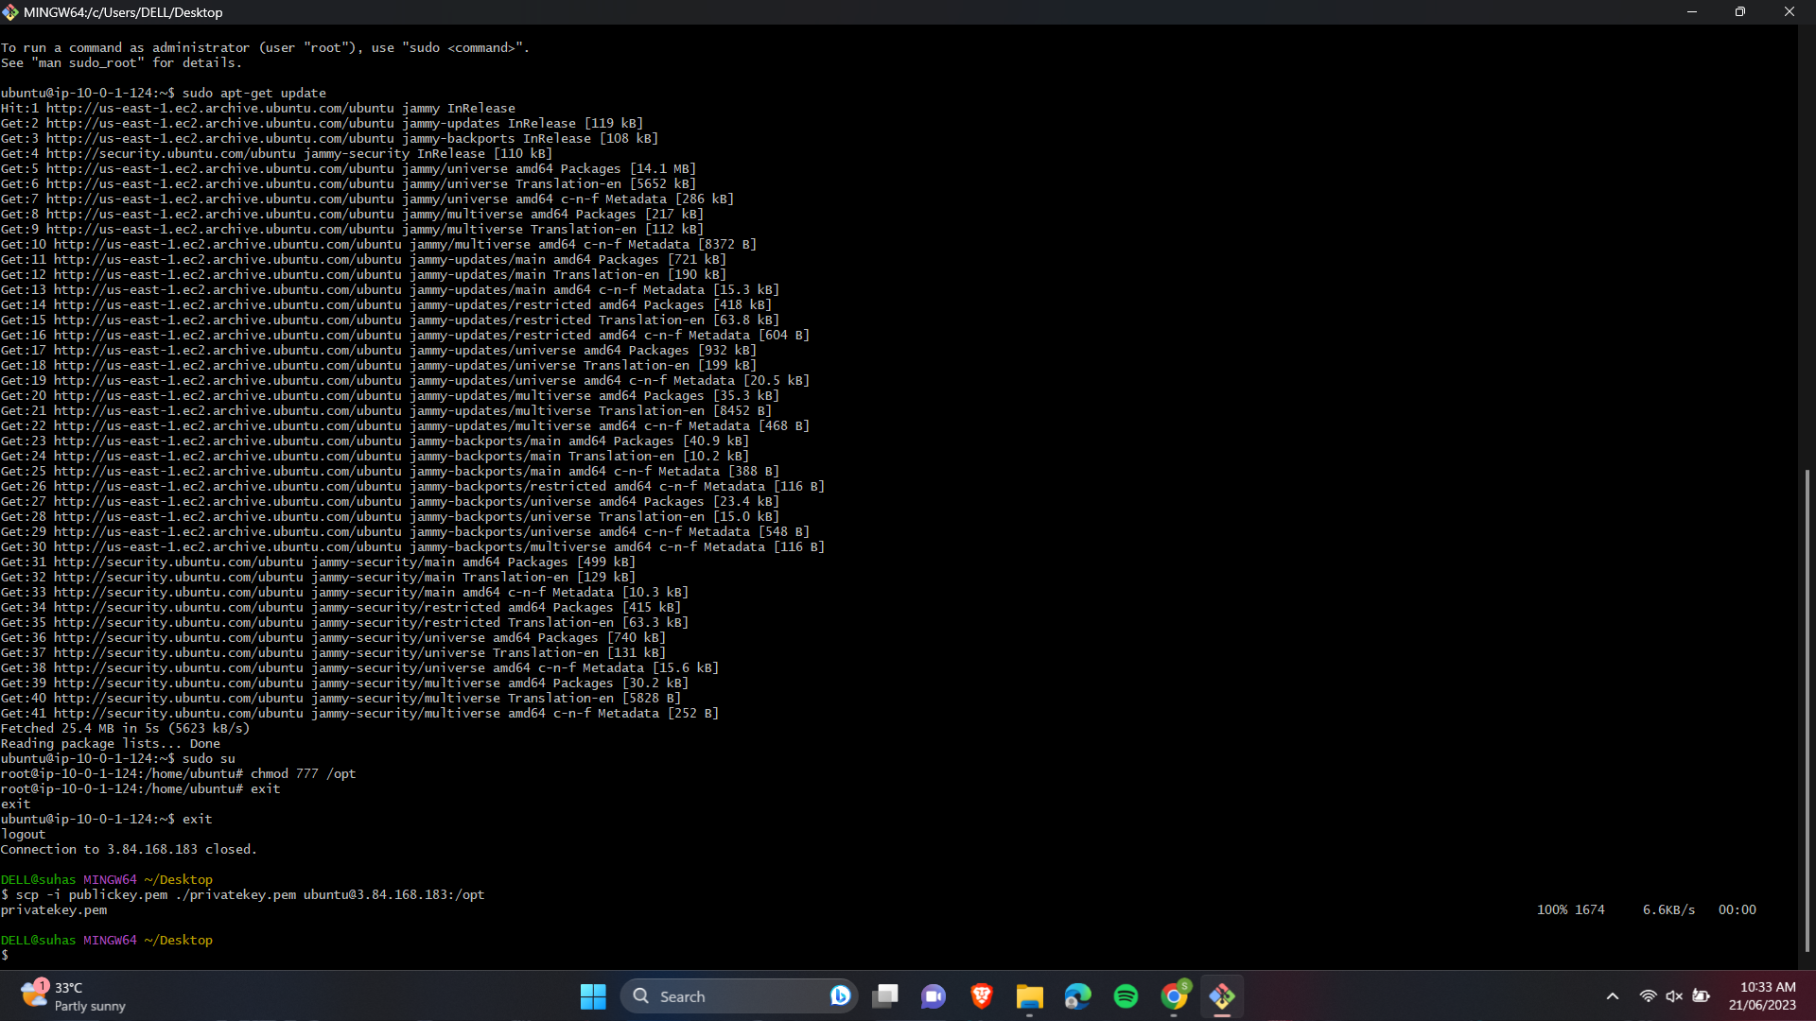

17.Copying the key-pair file of private instance into the opt folder of public instance. And connecting to public instance.

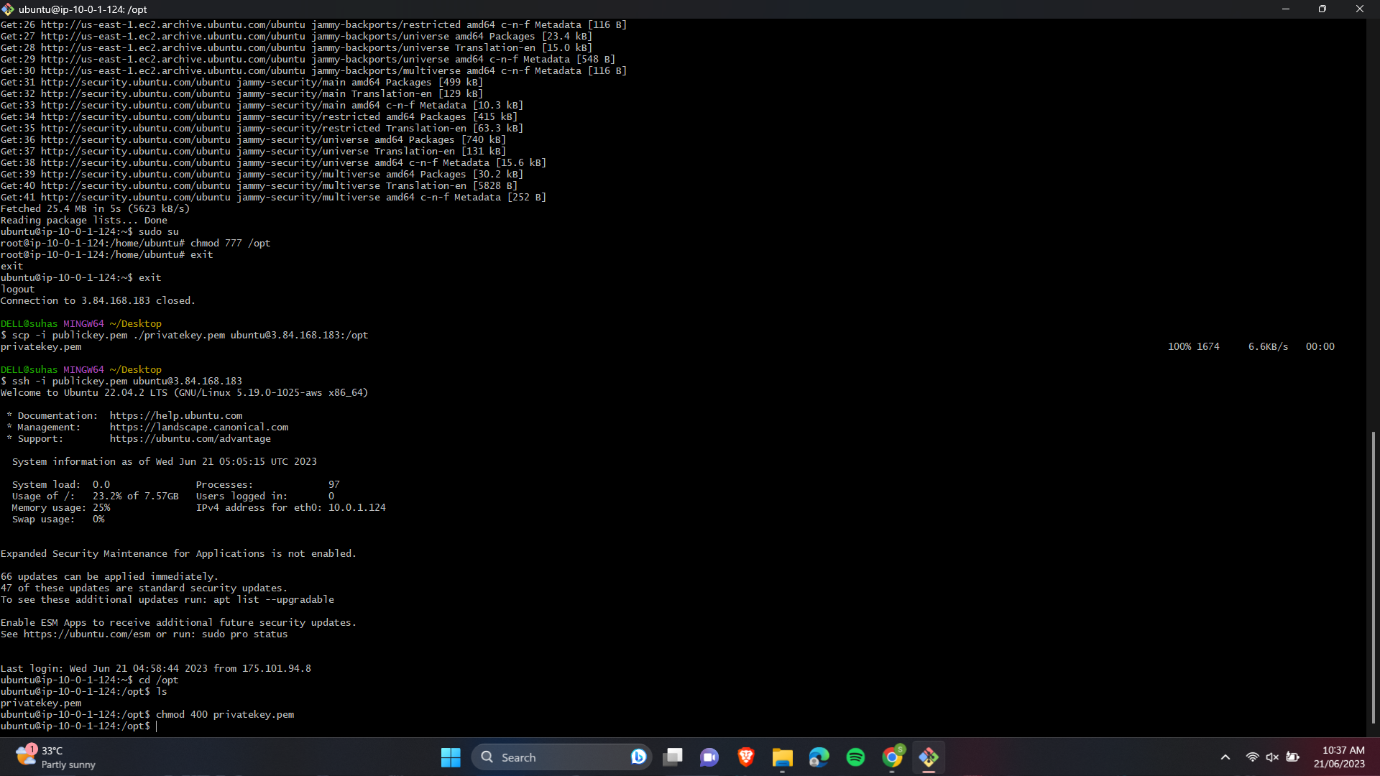

18.Changing the permissions of private key-pair file and connecting to private instance.

19.Now if you check ping google.com there is no traffic because our private instance is not connected to internet.

* Select the private instance and in actions go to security and stop source and destination checks. Now if you check you can see our private instance is connected to internet.